**LAPORAN PROGRES PEMBUATAN APLIKASI**



**Dosen Pembimbing :**

**SLAMET TRYANTO**

Disusun Oleh :

**JESIKA**

**202013010**

**PROGRAM STUDI TEKNIK INFORMATIKA**

**POLITEKNIK KAMPAR**

**2021**

**KATA PENGANTAR**

Assalamu’alaikum warahmatullahi wabarakatuh Segala puji bagi Allah SWT yang telah memberikan kami kemudahan sehingga kami dapat menyelesaikan makalah ini dengan tepat waktu. Tanpa pertolongan-Nya tentunya kami tidak akan sanggup untuk menyelesaikan makalah ini dengan baik. Shalawat serta salam semoga terlimpah curahkan kepada baginda tercinta kita yaitu Nabi Muhammad SAW yang kita nanti-natikan syafa’atnya di akhirat nanti. Penulis mengucapkan syukur kepada Allah SWT atas limpahan nikmat sehat-Nya, baik itu berupa sehat fisik maupun akal pikiran, sehingga penulis mampu untuk menyelesaikan pembuatan laporan progress pembuatan aplikasi sebagai tugas dari mata kuliah pemrograman berbasis objek. Penulis tentu menyadari bahwa laporan ini masih jauh dari kata sempurna dan masih banyak terdapat kesalahan serta kekurangan di dalamnya.

Untuk itu, penulis mengharapkan kritik serta saran dari pembaca untuk proposal ini, supaya proposal ini nantinya dapat menjadi proposal yang lebih baik lagi. Kemudian apabila terdapat banyak kesalahan pada proposal ini penulis mohon maaf yang sebesar-besarnya. Penulis juga mengucapkan terima kasih kepada semua pihak khususnya kepada dosen pengampuh kami yang telah membimbing dalam menulis proposal ini. Demikian, semoga proposal ini dapat bermanfaat. Terima kasih.

Bangkinang, 19 juli 2021

penulis

**BAB 1**

1. **Tampilan depan**

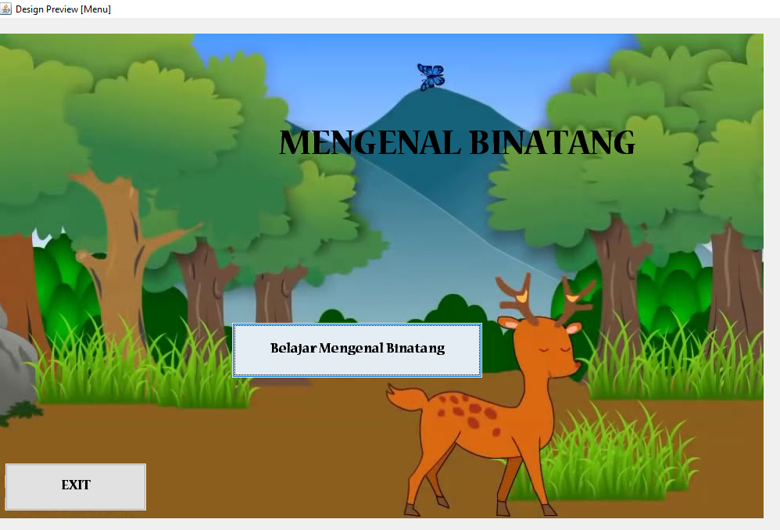

Penjelasan: gambar diatas adalah tampilan awal pada aplikasi mengenal binatang menggunakan NetBeans. Berikut adalah sourcode dari tampilan ini.

/*

* To change this license header, choose License Headers in Project Properties.

* To change this template file, choose Tools | Templates

* and open the template in the editor.

*/

/**

*

* @author hp

*/

public class Menu extends javax.swing.JFrame {

/**

* Creates new form Menu

*/

public Menu() {

initComponents();

}

/**

* This method is called from within the constructor to initialize the form.

* WARNING: Do NOT modify this code. The content of this method is always

* regenerated by the Form Editor.

*/

@SuppressWarnings("unchecked")

// <editor-fold defaultstate="collapsed" desc="Generated Code">

private void initComponents() {

jLabel2 = new javax.swing.JLabel();

jLabel1 = new javax.swing.JLabel();

jButton2 = new javax.swing.JButton();

jButton3 = new javax.swing.JButton();

cover = new javax.swing.JLabel();

jLabel2.setText("jLabel2");

setDefaultCloseOperation(javax.swing.WindowConstants.EXIT_ON_CLOSE);

getContentPane().setLayout(null);

jLabel1.setFont(new java.awt.Font("Nueva Std", 1, 48)); // NOI18N

jLabel1.setText("MENGENAL BINATANG");

getContentPane().add(jLabel1);

jLabel1.setBounds(360, 140, 500, 50);

jButton2.setFont(new java.awt.Font("Nueva Std", 1, 18)); // NOI18N

jButton2.setText("Belajar Mengenal Binatang");

jButton2.addActionListener(new java.awt.event.ActionListener() {

public void actionPerformed(java.awt.event.ActionEvent evt) {

jButton2ActionPerformed(evt);

}

});

getContentPane().add(jButton2);

jButton2.setBounds(300, 390, 320, 70);

jButton3.setFont(new java.awt.Font("Nueva Std", 1, 18)); // NOI18N

jButton3.setText("EXIT");

jButton3.addActionListener(new java.awt.event.ActionListener() {

public void actionPerformed(java.awt.event.ActionEvent evt) {

jButton3ActionPerformed(evt);

}

});

getContentPane().add(jButton3);

jButton3.setBounds(10, 570, 180, 60);

cover.setIcon(new javax.swing.ImageIcon(getClass().getResource("/abc.jpg"))); // NOI18N

getContentPane().add(cover);

cover.setBounds(-20, 20, 1000, 620);

pack();

}// </editor-fold>

private void jButton3ActionPerformed(java.awt.event.ActionEvent evt) {

System.exit(0);

}

private void jButton2ActionPerformed(java.awt.event.ActionEvent evt) {

new pilihanMenu().setVisible(true);

}

/**

* @param args the command line arguments

*/

public static void main(String args[]) {

/* Set the Nimbus look and feel */

//<editor-fold defaultstate="collapsed" desc=" Look and feel setting code (optional) ">

/* If Nimbus (introduced in Java SE 6) is not available, stay with the default look and feel.

* For details see http://download.oracle.com/javase/tutorial/uiswing/lookandfeel/plaf.html

*/

try {

for (javax.swing.UIManager.LookAndFeelInfo info : javax.swing.UIManager.getInstalledLookAndFeels()) {

if ("Nimbus".equals(info.getName())) {

javax.swing.UIManager.setLookAndFeel(info.getClassName());

break;

}

}

} catch (ClassNotFoundException ex) {

java.util.logging.Logger.getLogger(Menu.class.getName()).log(java.util.logging.Level.SEVERE, null, ex);

} catch (InstantiationException ex) {

java.util.logging.Logger.getLogger(Menu.class.getName()).log(java.util.logging.Level.SEVERE, null, ex);

} catch (IllegalAccessException ex) {

java.util.logging.Logger.getLogger(Menu.class.getName()).log(java.util.logging.Level.SEVERE, null, ex);

} catch (javax.swing.UnsupportedLookAndFeelException ex) {

java.util.logging.Logger.getLogger(Menu.class.getName()).log(java.util.logging.Level.SEVERE, null, ex);

}

//</editor-fold>

/* Create and display the form */

java.awt.EventQueue.invokeLater(new Runnable() {

public void run() {

new Menu().setVisible(true);

}

});

}

// Variables declaration - do not modify

private javax.swing.JLabel cover;

private javax.swing.JButton jButton2;

private javax.swing.JButton jButton3;

private javax.swing.JLabel jLabel1;

private javax.swing.JLabel jLabel2;

// End of variables declaration

}

1. **Tampilan menu**

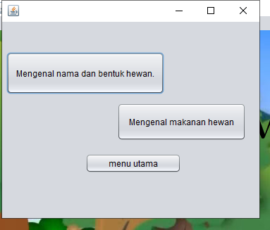

Penjelasan: gambar diatas merupakan tampilan menu menggunakan NetBeans. Berikut ini adalah sourcode yang digunakan dalam membuat tampilan menu.

/*

* To change this license header, choose License Headers in Project Properties.

* To change this template file, choose Tools | Templates

* and open the template in the editor.

*/

/**

*

* @author hp

*/

public class pilihanMenu extends javax.swing.JFrame {

/**

* Creates new form pilihanMenu

*/

public pilihanMenu() {

initComponents();

}

/**

* This method is called from within the constructor to initialize the form.

* WARNING: Do NOT modify this code. The content of this method is always

* regenerated by the Form Editor.

*/

@SuppressWarnings("unchecked")

// <editor-fold defaultstate="collapsed" desc="Generated Code">

private void initComponents() {

jButton1 = new javax.swing.JButton();

jButton2 = new javax.swing.JButton();

jButton3 = new javax.swing.JButton();

setDefaultCloseOperation(javax.swing.WindowConstants.EXIT_ON_CLOSE);

jButton1.setText("Mengenal nama dan bentuk hewan.");

jButton1.addActionListener(new java.awt.event.ActionListener() {

public void actionPerformed(java.awt.event.ActionEvent evt) {

jButton1ActionPerformed(evt);

}

});

jButton2.setText("Mengenal makanan hewan");

jButton3.setText("menu utama");

jButton3.addActionListener(new java.awt.event.ActionListener() {

public void actionPerformed(java.awt.event.ActionEvent evt) {

jButton3ActionPerformed(evt);

}

});

javax.swing.GroupLayout layout = new javax.swing.GroupLayout(getContentPane());

getContentPane().setLayout(layout);

layout.setHorizontalGroup(

layout.createParallelGroup(javax.swing.GroupLayout.Alignment.LEADING)

.addGroup(javax.swing.GroupLayout.Alignment.TRAILING, layout.createSequentialGroup()

.addGap(0, 0, Short.MAX_VALUE)

.addComponent(jButton2, javax.swing.GroupLayout.PREFERRED_SIZE, 183, javax.swing.GroupLayout.PREFERRED_SIZE)

.addGap(19, 19, 19))

.addGroup(layout.createSequentialGroup()

.addGroup(layout.createParallelGroup(javax.swing.GroupLayout.Alignment.LEADING)

.addGroup(layout.createSequentialGroup()

.addContainerGap()

.addComponent(jButton1))

.addGroup(layout.createSequentialGroup()

.addGap(118, 118, 118)

.addComponent(jButton3, javax.swing.GroupLayout.PREFERRED_SIZE, 136, javax.swing.GroupLayout.PREFERRED_SIZE)))

.addContainerGap(111, Short.MAX_VALUE))

);

layout.setVerticalGroup(

layout.createParallelGroup(javax.swing.GroupLayout.Alignment.LEADING)

.addGroup(layout.createSequentialGroup()

.addGap(43, 43, 43)

.addComponent(jButton1, javax.swing.GroupLayout.PREFERRED_SIZE, 60, javax.swing.GroupLayout.PREFERRED_SIZE)

.addPreferredGap(javax.swing.LayoutStyle.ComponentPlacement.UNRELATED)

.addComponent(jButton2, javax.swing.GroupLayout.PREFERRED_SIZE, 54, javax.swing.GroupLayout.PREFERRED_SIZE)

.addGap(18, 18, 18)

.addComponent(jButton3)

.addContainerGap(64, Short.MAX_VALUE))

);

pack();

}// </editor-fold>

private void jButton3ActionPerformed(java.awt.event.ActionEvent evt) {

new Menu().setVisible(true);

}

private void jButton1ActionPerformed(java.awt.event.ActionEvent evt) {

}

/**

* @param args the command line arguments

*/

public static void main(String args[]) {

/* Set the Nimbus look and feel */

//<editor-fold defaultstate="collapsed" desc=" Look and feel setting code (optional) ">

/* If Nimbus (introduced in Java SE 6) is not available, stay with the default look and feel.

* For details see http://download.oracle.com/javase/tutorial/uiswing/lookandfeel/plaf.html

*/

try {

for (javax.swing.UIManager.LookAndFeelInfo info : javax.swing.UIManager.getInstalledLookAndFeels()) {

if ("Nimbus".equals(info.getName())) {

javax.swing.UIManager.setLookAndFeel(info.getClassName());

break;

}

}

} catch (ClassNotFoundException ex) {

java.util.logging.Logger.getLogger(pilihanMenu.class.getName()).log(java.util.logging.Level.SEVERE, null, ex);

} catch (InstantiationException ex) {

java.util.logging.Logger.getLogger(pilihanMenu.class.getName()).log(java.util.logging.Level.SEVERE, null, ex);

} catch (IllegalAccessException ex) {

java.util.logging.Logger.getLogger(pilihanMenu.class.getName()).log(java.util.logging.Level.SEVERE, null, ex);

} catch (javax.swing.UnsupportedLookAndFeelException ex) {

java.util.logging.Logger.getLogger(pilihanMenu.class.getName()).log(java.util.logging.Level.SEVERE, null, ex);

}

//</editor-fold>

/* Create and display the form */

java.awt.EventQueue.invokeLater(new Runnable() {

public void run() {

new pilihanMenu().setVisible(true);

}

});

}

// Variables declaration - do not modify

private javax.swing.JButton jButton1;

private javax.swing.JButton jButton2;

private javax.swing.JButton jButton3;

// End of variables declaration

}

1. **Tampilan menu**

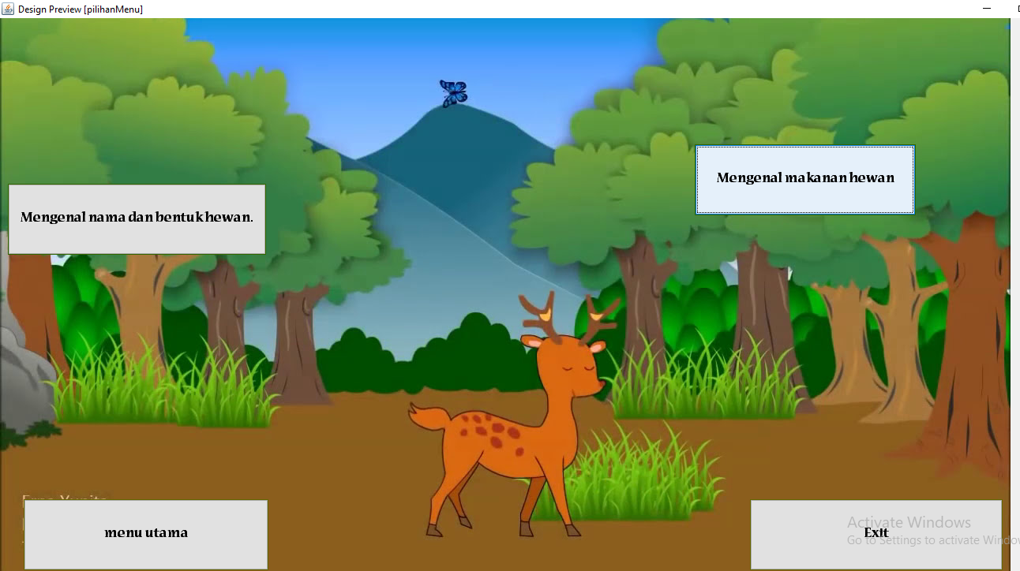

Penjelasan: gambar diatas merupakan tampilan menu menggunakan NetBeans yang telah diberikan background. Berikut ini adalah sourcode yang digunakan dalam membuat tampilan menu.

/*

* To change this license header, choose License Headers in Project Properties.

* To change this template file, choose Tools | Templates

* and open the template in the editor.

*/

/**

*

* @author hp

*/

public class pilihanMenu extends javax.swing.JFrame {

/**

* Creates new form pilihanMenu

*/

public pilihanMenu() {

initComponents();

}

/**

* This method is called from within the constructor to initialize the form.

* WARNING: Do NOT modify this code. The content of this method is always

* regenerated by the Form Editor.

*/

@SuppressWarnings("unchecked")

// <editor-fold defaultstate="collapsed" desc="Generated Code">

private void initComponents() {

jButton1 = new javax.swing.JButton();

jButton2 = new javax.swing.JButton();

jButton3 = new javax.swing.JButton();

exit = new javax.swing.JButton();

latar = new javax.swing.JLabel();

setDefaultCloseOperation(javax.swing.WindowConstants.EXIT_ON_CLOSE);

getContentPane().setLayout(null);

jButton1.setBackground(new java.awt.Color(51, 102, 0));

jButton1.setFont(new java.awt.Font("Nueva Std", 1, 18)); // NOI18N

jButton1.setText("Mengenal nama dan bentuk hewan.");

jButton1.addActionListener(new java.awt.event.ActionListener() {

public void actionPerformed(java.awt.event.ActionEvent evt) {

jButton1ActionPerformed(evt);

}

});

getContentPane().add(jButton1);

jButton1.setBounds(10, 210, 327, 90);

jButton2.setBackground(new java.awt.Color(51, 102, 0));

jButton2.setFont(new java.awt.Font("Nueva Std", 1, 18)); // NOI18N

jButton2.setText("Mengenal makanan hewan");

getContentPane().add(jButton2);

jButton2.setBounds(880, 160, 280, 90);

jButton3.setBackground(new java.awt.Color(102, 102, 0));

jButton3.setFont(new java.awt.Font("Nueva Std", 1, 18)); // NOI18N

jButton3.setText("menu utama");

jButton3.addActionListener(new java.awt.event.ActionListener() {

public void actionPerformed(java.awt.event.ActionEvent evt) {

jButton3ActionPerformed(evt);

}

});

getContentPane().add(jButton3);

jButton3.setBounds(30, 610, 310, 90);

exit.setBackground(new java.awt.Color(102, 102, 0));

exit.setFont(new java.awt.Font("Nueva Std", 1, 18)); // NOI18N

exit.setText("Exit");

exit.addActionListener(new java.awt.event.ActionListener() {

public void actionPerformed(java.awt.event.ActionEvent evt) {

exitActionPerformed(evt);

}

});

getContentPane().add(exit);

exit.setBounds(950, 610, 320, 90);

latar.setIcon(new javax.swing.ImageIcon(getClass().getResource("/abc.jpg"))); // NOI18N

getContentPane().add(latar);

latar.setBounds(0, -10, 1320, 720);

pack();

}// </editor-fold>

private void jButton3ActionPerformed(java.awt.event.ActionEvent evt) {

new Menu().setVisible(true);

}

private void jButton1ActionPerformed(java.awt.event.ActionEvent evt) {

new MengenalNama().setVisible(true);

}

private void exitActionPerformed(java.awt.event.ActionEvent evt) {

System.exit(0);

}

/**

* @param args the command line arguments

*/

public static void main(String args[]) {

/* Set the Nimbus look and feel */

//<editor-fold defaultstate="collapsed" desc=" Look and feel setting code (optional) ">

/* If Nimbus (introduced in Java SE 6) is not available, stay with the default look and feel.

* For details see http://download.oracle.com/javase/tutorial/uiswing/lookandfeel/plaf.html

*/

try {

for (javax.swing.UIManager.LookAndFeelInfo info : javax.swing.UIManager.getInstalledLookAndFeels()) {

if ("Nimbus".equals(info.getName())) {

javax.swing.UIManager.setLookAndFeel(info.getClassName());

break;

}

}

} catch (ClassNotFoundException ex) {

java.util.logging.Logger.getLogger(pilihanMenu.class.getName()).log(java.util.logging.Level.SEVERE, null, ex);

} catch (InstantiationException ex) {

java.util.logging.Logger.getLogger(pilihanMenu.class.getName()).log(java.util.logging.Level.SEVERE, null, ex);

} catch (IllegalAccessException ex) {

java.util.logging.Logger.getLogger(pilihanMenu.class.getName()).log(java.util.logging.Level.SEVERE, null, ex);

} catch (javax.swing.UnsupportedLookAndFeelException ex) {

java.util.logging.Logger.getLogger(pilihanMenu.class.getName()).log(java.util.logging.Level.SEVERE, null, ex);

}

//</editor-fold>

/* Create and display the form */

java.awt.EventQueue.invokeLater(new Runnable() {

public void run() {

new pilihanMenu().setVisible(true);

}

});

}

// Variables declaration - do not modify

private javax.swing.JButton exit;

private javax.swing.JButton jButton1;

private javax.swing.JButton jButton2;

private javax.swing.JButton jButton3;

private javax.swing.JLabel latar;

// End of variables declaration

}

1. **Menu mengenal nama dan bentuk hewan**

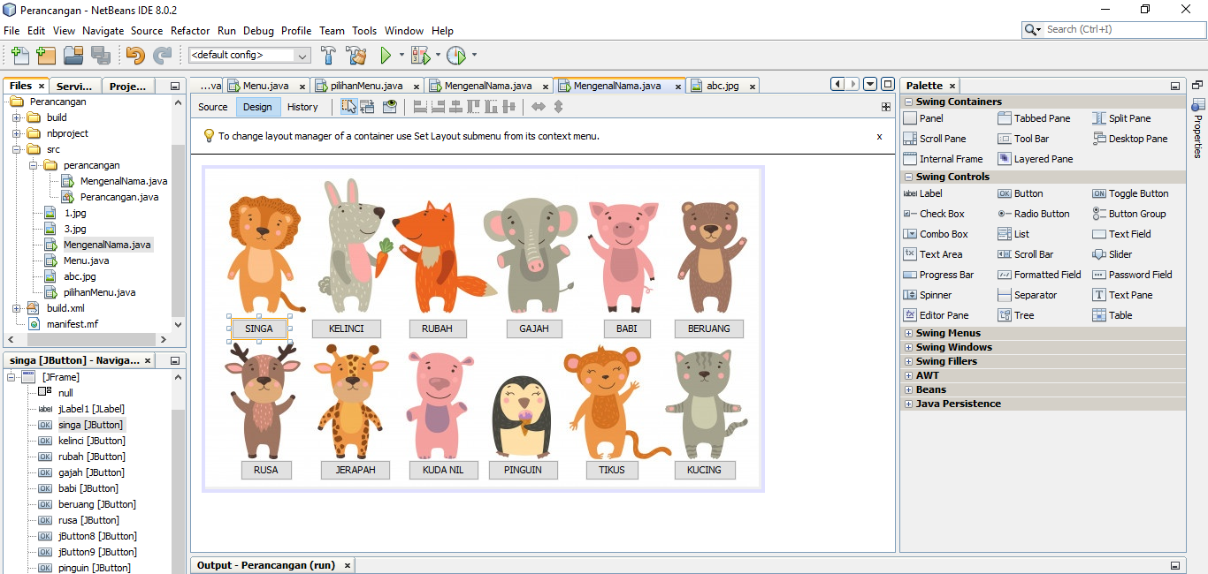

Penjelasan: gambar diatas merupakan tampilan menu mengenal nama dan bentung hewan menggunakan NetBeans yang telah diberikan background. Berikut ini adalah sourcode yang digunakan dalam membuat tampilan menu.

/*

* To change this license header, choose License Headers in Project Properties.

* To change this template file, choose Tools | Templates

* and open the template in the editor.

*/

/**

*

* @author hp

*/

public class MengenalNama extends javax.swing.JFrame {

/**

* Creates new form MengenalNama

*/

public MengenalNama() {

initComponents();

}

/**

* This method is called from within the constructor to initialize the form.

* WARNING: Do NOT modify this code. The content of this method is always

* regenerated by the Form Editor.

*/

@SuppressWarnings("unchecked")

// <editor-fold defaultstate="collapsed" desc="Generated Code">

private void initComponents() {

jButton1 = new javax.swing.JButton();

jLabel1 = new javax.swing.JLabel();

singa = new javax.swing.JButton();

kelinci = new javax.swing.JButton();

rubah = new javax.swing.JButton();

gajah = new javax.swing.JButton();

babi = new javax.swing.JButton();

beruang = new javax.swing.JButton();

rusa = new javax.swing.JButton();

jButton8 = new javax.swing.JButton();

jButton9 = new javax.swing.JButton();

pinguin = new javax.swing.JButton();

TIKUS = new javax.swing.JButton();

kucing = new javax.swing.JButton();

jLabel2 = new javax.swing.JLabel();

jButton1.setText("jButton1");

setDefaultCloseOperation(javax.swing.WindowConstants.EXIT_ON_CLOSE);

getContentPane().setLayout(null);

getContentPane().add(jLabel1);

jLabel1.setBounds(0, 0, 0, 0);

singa.setText("SINGA");

singa.addActionListener(new java.awt.event.ActionListener() {

public void actionPerformed(java.awt.event.ActionEvent evt) {

singaActionPerformed(evt);

}

});

getContentPane().add(singa);

singa.setBounds(30, 170, 63, 23);

kelinci.setText("KELINCI");

getContentPane().add(kelinci);

kelinci.setBounds(120, 170, 80, 23);

rubah.setText("RUBAH");

getContentPane().add(rubah);

rubah.setBounds(230, 170, 67, 23);

gajah.setText("GAJAH");

getContentPane().add(gajah);

gajah.setBounds(340, 170, 65, 23);

babi.setText("BABI");

getContentPane().add(babi);

babi.setBounds(450, 170, 55, 23);

beruang.setText("BERUANG");

getContentPane().add(beruang);

beruang.setBounds(530, 170, 80, 23);

rusa.setText("RUSA");

getContentPane().add(rusa);

rusa.setBounds(40, 330, 59, 23);

jButton8.setText("JERAPAH");

getContentPane().add(jButton8);

jButton8.setBounds(130, 330, 80, 23);

jButton9.setText("KUDA NIL");

getContentPane().add(jButton9);

jButton9.setBounds(230, 330, 80, 23);

pinguin.setText("PINGUIN");

getContentPane().add(pinguin);

pinguin.setBounds(320, 330, 80, 23);

TIKUS.setText("TIKUS");

getContentPane().add(TIKUS);

TIKUS.setBounds(430, 330, 61, 23);

kucing.setText("KUCING");

getContentPane().add(kucing);

kucing.setBounds(530, 330, 71, 23);

jLabel2.setIcon(new javax.swing.ImageIcon(getClass().getResource("/3.jpg"))); // NOI18N

getContentPane().add(jLabel2);

jLabel2.setBounds(0, 0, 630, 360);

pack();

}// </editor-fold>

private void singaActionPerformed(java.awt.event.ActionEvent evt) {

// TODO add your handling code here:

}

/**

* @param args the command line arguments

*/

public static void main(String args[]) {

/* Set the Nimbus look and feel */

//<editor-fold defaultstate="collapsed" desc=" Look and feel setting code (optional) ">

/* If Nimbus (introduced in Java SE 6) is not available, stay with the default look and feel.

* For details see http://download.oracle.com/javase/tutorial/uiswing/lookandfeel/plaf.html

*/

try {

for (javax.swing.UIManager.LookAndFeelInfo info : javax.swing.UIManager.getInstalledLookAndFeels()) {

if ("Nimbus".equals(info.getName())) {

javax.swing.UIManager.setLookAndFeel(info.getClassName());

break;

}

}

} catch (ClassNotFoundException ex) {

java.util.logging.Logger.getLogger(MengenalNama.class.getName()).log(java.util.logging.Level.SEVERE, null, ex);

} catch (InstantiationException ex) {

java.util.logging.Logger.getLogger(MengenalNama.class.getName()).log(java.util.logging.Level.SEVERE, null, ex);

} catch (IllegalAccessException ex) {

java.util.logging.Logger.getLogger(MengenalNama.class.getName()).log(java.util.logging.Level.SEVERE, null, ex);

} catch (javax.swing.UnsupportedLookAndFeelException ex) {

java.util.logging.Logger.getLogger(MengenalNama.class.getName()).log(java.util.logging.Level.SEVERE, null, ex);

}

//</editor-fold>

/* Create and display the form */

java.awt.EventQueue.invokeLater(new Runnable() {

public void run() {

new MengenalNama().setVisible(true);

}

});

}

// Variables declaration - do not modify

private javax.swing.JButton TIKUS;

private javax.swing.JButton babi;

private javax.swing.JButton beruang;

private javax.swing.JButton gajah;

private javax.swing.JButton jButton1;

private javax.swing.JButton jButton8;

private javax.swing.JButton jButton9;

private javax.swing.JLabel jLabel1;

private javax.swing.JLabel jLabel2;

private javax.swing.JButton kelinci;

private javax.swing.JButton kucing;

private javax.swing.JButton pinguin;

private javax.swing.JButton rubah;

private javax.swing.JButton rusa;

private javax.swing.JButton singa;

// End of variables declaration

}